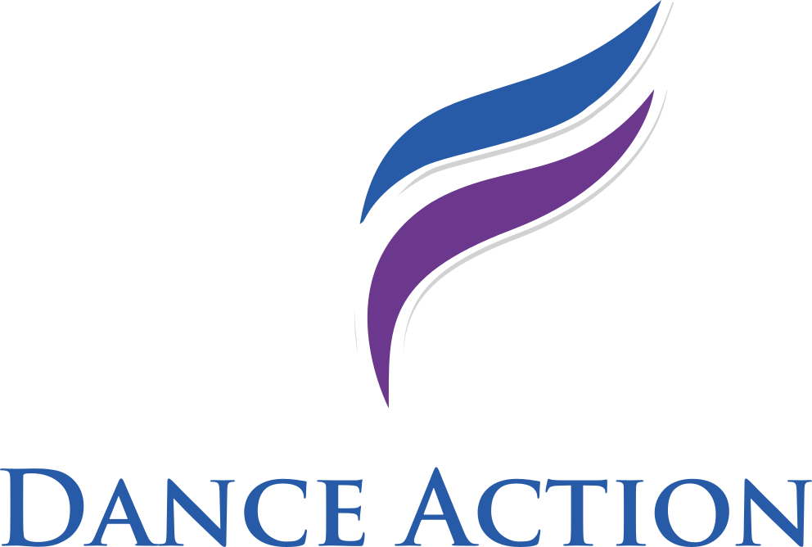

Dance is a great way to communicate and is the reason why we take care to nurture and develop the joy of Dance in everyone we teach.

Join us for classes here at Jubilee Hall, Eaton Socon and experience first class teaching and coaching with our experienced professionals.

ADULTS ONLY

MONDAYS: 7.15 to 8.15pm Beginners Ballroom and Latin American
8.15 to 8.30pm Practice
8.30 to 9.30pm Improvers Ballroom and Latin American

THURSDAYS: 7.00 to 8.00pm Beginners Ballroom and Latin American
8.00 to 8.30pm Practice
8.30 to 10.00pm Intermediate Ballroom and Latin American

All classes are £7.50 pp
Practice Sessions between classes and Tea and Coffee are complimentary to attending class members

Tel: Lynn Armsby on 01480 839066
Email: info@danceaction.co.uk

Director, Examiner and Fellow of the
International Dance Teachers Association

